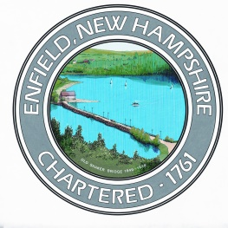 | Town of Enfield  Human Services Department  74 Lockehaven Road, P.O. Box 373  Enfield, New Hampshire 03748

ORGANIZATION ELIGIBILITY AND APPLICATION FORM

A completed & signed form is required of any Regional Association
requesting funding from the Town.

Organization’s Legal Name:
Street Address:
Mailing Address:
Website URL:

Primary Contact
Name:
Phone:
Email:

Organization’s Officers
Executive Director: Phone:
Board President: Phone:

ORGANIZATION AND APPLICATION INFORMATION

[Attach additional pages as needed to answer these questions]

Year of incorporation:
Mission statement:

Describe your organization’s services and who is eligible to receive them.
Indicate and restrictions regarding age, income, residence, etc.

How many Enfield residents does your organization serve each year?

How many other towns in the Upper Valley does your organization serve each year?
Please indicate the proportion of services provided to Enfield compared to other communities by your organization in the region.

Amount of funds requested:
If applicable, indicate amount of funds received in the previous year and document how they were used (including, for example, a copy of the narrative from last year’s Town Report.

ORGANIZATION ELIGIBILITY CRITERIA

Does your organization…

Have 501(c)(3) tax-exempt status?
Have a volunteer Board of Directors with at least five non-employee members?
Are less than 14% of the Board members employees (or otherwise paid)?
How many meetings of the governing body are held each year?

GUARANTEE OF FINANCIAL INTEGRITY
The Town of Enfield strives to ensure that taxpayer dollars are spent in a responsible manner. We therefore require that organizations receiving town funds meet a standard of integrity and that individuals representing those organizations have no history of previous financial misdealing.

I hereby certify on behalf of the organization noted below that no staff or board member with access to agency funds has a previous felony conviction for a financial crime. *

Name of Organization:
Board President’s Name:
Board President’s Signature: Date:

*These include any crimes of dishonesty (including fraud), breach of trust, or money laundering (see U.S.C. 1829.) Please note that under this section of the federal law, pre-trial diversion and similar programs are convictions

